Unit 3 Study Guide- Español 1
- Culture
  - Cuban independence
  - Cuban Salsa dance
  - Celia Cruz
  - Capital de Cuba
  - Fidel Castro vs. U.S.
- Noun-Adjective Agreement- translate the following:
  - A blue book
  - A pink pencil
  - A black eraser
  - A short girl
  - Some white papers
  - Some red apples
  - Some red markers
  - The blue crayon
  - The yellow table
  - The green door
  - The tall boy
- Subject Pronouns
I = | We (m)  We (f)
You (informal)= | You all *Spain (m)=  You all *Spain (f)=
You (formal)=  He=  She= | You all (Latin America)=  They (m)  They (f)
- ¿Qué hora es?- write out how to say the time of the following:
  - 3: 30 a.m.
  - 2:00
  - 5:15 a.m.
  - 7:35 p.m.
  - 12:45
  - 12:00 p.m.
- Colors and Spanish Definite Articles: el, la, los, las.
  - The clock is orange.
  - The scissors are pink.
  - The computer is green.
  - The erasers are blue.
  - The chair is yellow.
  - Ms. Metcalf’s desk is brown.
- Body Parts
Label the following:  El pelo  El pie  La pierna  El codo  La rodilla  El hombro  La oreja  El ojo  La nariz  El cuello  Los dedos  La mano  El estómago  La cintura  El brazo  La cabeza  La boca | 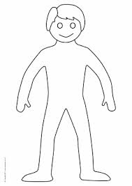
- El Mapa- Label Cuba on the map below
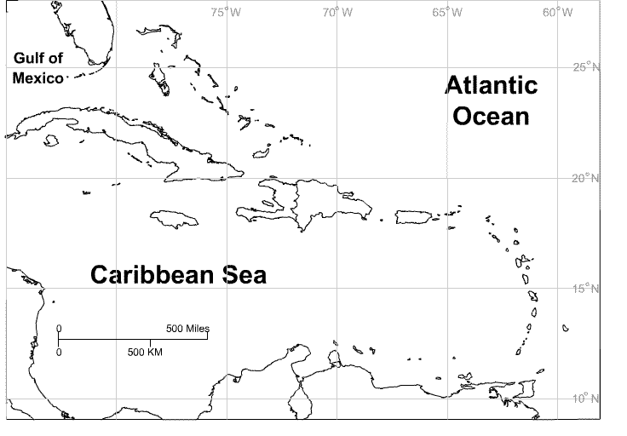
- Gustar: Write 5 sentences using gustar (gusta/gustan).

